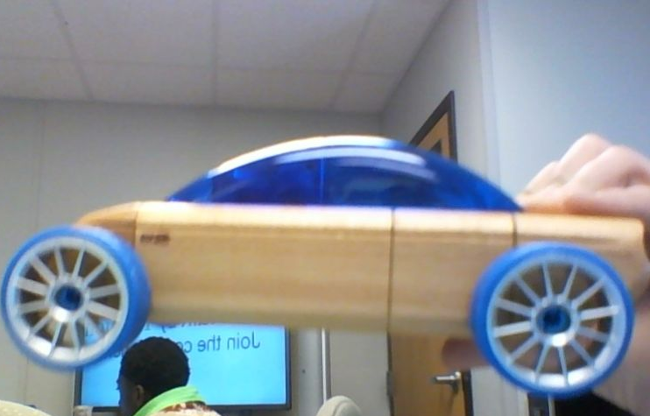
Automoblox S9 Sedan
Side: This view projects the depth of the car very well.
The car is horizontal. It has a curved line on top of parallel
Straight lines. There is a contrast between the blue color
And the tan color of the car. It is composed of a rectangle,
a semi-circle and 2 circles (in this view) on the botom of
The rectangle. It has a fairly smooth texture and a symm-
trical balance. It draws some emphasis towards the top of
because of the solid blue that is there. There is a consitant
rhythm with the spokes of the wheel. All objects appear to
be in proportion with one another.

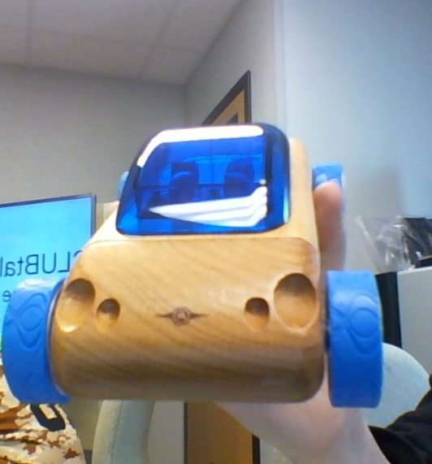Front
This view shows the height and width of the car
Very well. It is shown along a horizontal line (its
Width). It shows a contrast between the tan and blue
Color of the car. It shows that there are holes of different
Depths and sizes on the front side of the car. It is composed
Of 2 circles and some rectangles. It has a symmetrical balance
And a rough texture along the circles on the side but a smoother
Texture along the front. It draws some emphasis towards the top of
because of the solid blue that is there. There is a consistant rhythm with
the pattern on the blue portion of the wheel. All objects appear to be in
proportion with one another.

Top
This shows the width and the depth of the view greatly here.
It is along a vertical line (its depth).There is a very good contrast
Between the blue which is the dominant color here, against the
Tan color. There is a lot of emphasis towards the top, and the blue
As it is a very vibrant shade of blue in this image. It is composed
Of 4 circles, a rectangle and what in this image is shown as a curved
Edged rectangle. It has a very symmetrical balance and will have a smooth
Texture along everywhere except the wheels. There is a consistant rhythm
With the pattern on the wheels, the people in the car and the holes on the
Front of the car. All objects appear to be in proportion with one another.

