Activity 6.3 Functional Analysis Automoblox

Introduction
You have performed a visual analysis of your Automoblox vehicle to identify the visual design principles and elements that give the object its visual appeal, or lack thereof. The next step in the reverse engineering process involves the study of the object’s function. This is done through careful observation of the object’s sequential operation before it is disassembled. By first observing the product, you can hypothesize how a product operates and then compare your predictions to your actual findings after the part is dissected.

In this activity, you will perform a functional analysis of your Automoblox vehicle

Equipment
Example product observation
- Engineering notebook
- Pencil
- Automoblox vehicle

Procedure
Before measurement and dissection, theorize how the various sub-systems of the toy function through non-destructive observation. Study the toy and then respond to the following.

Product Name:
Company Name:

- What is the purpose or primary function of the object?

- Sketch an isometric pictorial of the product in your engineering notebook and label the individual components. If you are not sure what a particular component is called, then make a logical guess.

- Make an educated guess regarding each of the following.
  - Without removing any wheels from the vehicle, explain what design detail(s) allow the wheels to rotate freely while remaining attached to the axle pin?

  - Remove a wheel and examine the design of the wheel and axle pin. Was your hypothesis correct? If not, describe the operation of the wheel and axle that allows free rotation but secures the wheel to the axle pin.

  - Without disassembling the vehicle, hypothesize how the connector pieces (including all three separate pieces that make up the connector assembly) securely attach the body parts together while allowing easy disassembly by a child when an adequate force is applied.

  - Disassemble the vehicle and examine the connector pieces. Was your hypothesis on the operation of the connector pieces correct? If not, describe the operation of connector pieces such that connector assembly securely attaches the body parts together while allowing easy disassembly by a child.

  - What is the purpose of the raised ridge pattern on the top and bottom center clips of the connector piece?

  - What other elements of the product design appear to have a specific function or design intent? Consider the choice of materials, form/size of various pieces of the vehicle, durability, target market, and ease-of-use. Ask yourself, “Why did the designer make this choice?”

- Identify the system inputs, intended product function, and outputs in the table below.
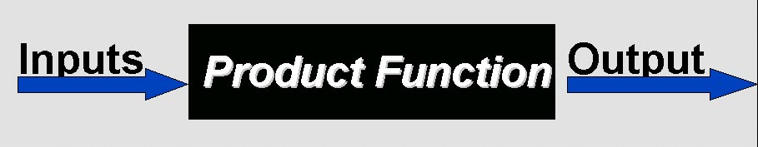
Inputs | Product Function | Output

Conclusion
- Why do engineers perform reverse engineering on products?

- What does a blaq1ck box represent in the system input/output model?

