Activity 6.4 Structural Analysis Automoblox

Introduction
You have already performed a Visual Analysis and a Functional Analysis of your Automoblox vehicle. During this activity you will investigate vital product characteristics with regard to the structure of the product. You will research and document your findings using careful measurements, sketches, and notes which will complete the reverse engineering of your product. You will use the information you have gathered during the process in the next unit when you design an enhancement or accessory for the Automoblox vehicle.

Equipment
- Engineering notebook
- Pencil
- Automoblox vehicle
- Graph and isometric grid paper
- Product Disassembly Chart
- Materials Usages Chart

Procedure
Identify each part of the Automoblox vehicle by name, quantity, size, function, material, finish, interaction of parts, and general notes using the Product Disassembly Chart to record your work.

- Create pictorial sketches, as necessary, to communicate the internal operation of the product.
- If you have not already done so, carefully measure each part using appropriate measuring devices.
- If you have not already done so, create annotated sketches of each part including an isometric pictorial (at least) and orthographic projections (as necessary) to detail the part with dimensions, material, and other characteristics. You may simply need to add annotations to sketches that you have previously created.
- Consider the choice of materials for the toy. For each part listed below, research the material used. Then either justify the choice of material or present an alternate material that you believe would be more appropriate for the part. Include mass, workability (in manufacturing), durability, strength, transparency, frictional properties, flexibility, and resistance to fatigue (failure due to repetitive use) in entries.
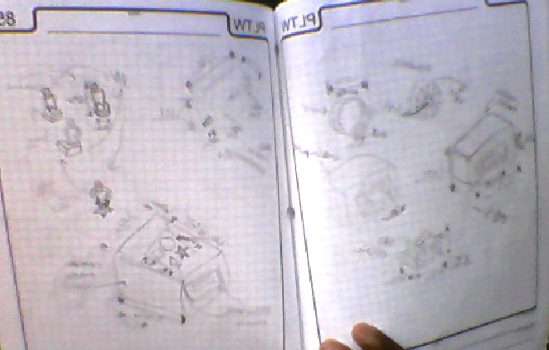

Part | Material | Justification or Alternate
Windshield | Polycarbonate | It is very strong, and very durable, it is also partly transparent giving it realism.
Tire | Rubber | Generates friction giving it good traction
Body | Hardwood | Very smooth, durable, gives the car a good design
Connector | ABS | Strong and Durable allowing for the cars to stay connected easily.
Axle | Proprietary polycarbonate blend (which includes a lubricant) | Strong and durable, allows for wheels to stay on and be removed easily while not interfering with their movement or friction.

- Complete the Product Disassembly Chart to detail important aspects of each part.

Sample Annotated Sketch of Part Documentation
The following is an example of a part documentation using an isometric sketch with annotated notes of fillet, hole location, materials, finish part location, and interactive parts.

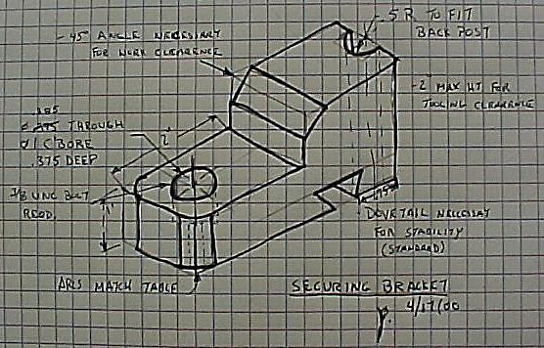

Conclusion

- Describe the process of Reverse Engineering.

- Part of the mission of Automoblox is to “offer a high quality building system that will delight and inspire children while fostering the development of important skills and learning foundations.” If given the opportunity, how would you improve the Automoblox design (visually, functionally, or structurally) while furthering the mission of the company at minimal cost?

